Enhancing Road Safety with Real-time Driver Drowsiness Detection Using Machine Learning

Lalitha Aradhini Kusampudi
Information Technology
Institute of Aeronautical Engineering
Hyderabad,India
lalithaaradhini@gmail.com

Shaik Mohammed Sharfuddin
Information Technology
Institute of Aeronautical Engineering
Hyderabad, India
shaiksharf609@gmail.com

Rama Devi Burri
Information Technology
Institute of Aeronautical Engineering
Hyderabad,India
ramaburri5@gmail.com

Nandigam Venkata Siva Sai
Information Technology
Institute of Aeronautical Engineering
Hyderabad,India
venkatshivasai014@gmail.com

Abstract—In these days there has been greater concern about the driver's drowsiness on road safety. According to the survey of the National Highway Traffic Safety Administration (NHTSA) a greater percentage of fatalities, injuries and even deaths every year is because of drowsy driving. So, there is an immediate necessity to implement a system which detects the drowsiness of the driver and alerts the driver. These systems, which rely on visual behaviour analysis, hold the potential to significantly decrease accidents by providing timely alerts when drivers exhibit signs of drowsiness. These systems make use of cameras and computer vision algorithms, such as the Haar cascade classifier and CNN. These systems scrutinize facial features, eye movements, and other indicators to assess levels of alertness and identify signs of drowsiness. The cameras that are integrated continuously capture facial expressions, enabling the evaluation of eyelid closure for the Eye Aspect Ratio (EAR) and Mouth aspect ratio (MAR) across frames. If predefined thresholds for EAR values are surpassed, an alert system triggers, notifying both the driver and passengers. The real-time detection of driver drowsiness, reliant on visual behaviour analysis, carries immense potential to save lives, curtail accidents, and enhance economic outcomes. By promptly alerting drivers to their drowsy state, these systems serve as crucial preventatives of accidents while promoting safer driving practices.

Keywords—Haarcascade classifier, Convolutional neural network, Eye aspect ratio, Mouth aspect ratio, OpenCV

Introduction
According to the research carried out by NHTSA [26], out of 3573 fatal crashes,684 were reported due to drowsy driving. This sums up to 19.14% of all fatal crashes. So, there is a need of implementing a system that alerts drivers when they are found drowsy. Machine Learning technologies, which are subset of artificial intelligence have evolved in a way that one can create some powerful systems by harnessing its capabilities. One such system is the Real-time driver drowsiness detection system. This system utilizes the Haar Cascade algorithm. Haar cascade is one of the machine learning methods to detect a driver's drowsiness in real time and prevent major accidents from occurring. Using machine learning in the realm of safety applications can unlock many possibilities of safety protocols, and real time drowsiness detection would be an inception to the machine learning capabilities in safety applications.
This technology conducts constant analysis of facial cues [9] like eye movements and other key markers to identify the driver’s fatigue state. For improvement of drowsiness detection in digital environments, the use of machine learning algorithms plays an important role in detecting the driver’s safety. This system signifies the aim towards an accurate and robust system which can deliver promising results and be utilized in real time environments. The key aim of this system is not only to detect driver drowsiness, but also to alert the driver dynamically about his state, enabling a more secure and efficient mechanism to improve the safety. Figure 1 describes the way in which an alarm should be triggered when clues of drowsiness are detected.
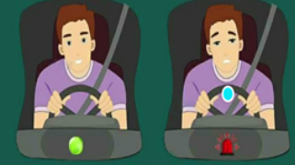
Fig. 1. Driver Drowsiness

RELATED WORK
There are various studies that were carried out to provide an efficient drowsiness detection system. Rama Devi Burri [1] presented a novel model for drowsiness detection using MTCNN algorithm. The model aims to calculate EAR and MAR ratios and alerts the drivers by sending the messages. A system was proposed by Kumar and Patra [2] which concentrated on SVM and HOG to detect drowsiness. Few studies [3][12][14] employed a system which takes blink rate, eye closure[17] and yawning into consideration and used a real-time dataset which focused on facial characteristics and their combination. Another study [21] focused on CNN for drowsiness detection.
Dua et al [4] proposed a model that analysed drivers eye status. Praveen Kumar et al. [5] introduced a Driver assistance system with Haar cascade. Addressing drowsiness, the system enhances vehicle stability and prevents accidents through interconnected modules. Dasgupta, Rahman, and Routray [6] propose a three-stage smartphone-based drowsiness detection system for drivers. Wei-Liang Ou [7] and team introduced an adaptive video-based drowsy driver detection system with a near-infrared-ray (NIR) camera. Achieving 94% open/closed eyes detection rates (without glasses), 78% (with glasses), and 91% accuracy in drowsy status detection. Few [10][16] other implementations focused on android applications for alerting drivers and human factors [19][23][24] in assessment.

PROPOSED SYSTEM
The proposed system makes use of a haar cascade classifier [13] along with a convolutional neural network (CNN) to detect the signs of drowsiness in drivers. The system that is proposed starts with capturing the face of the driver with the help of an integrated camera that uses OpenCV [22]. It uses a haar cascade classifier to extract the features and regions of interest like eyes and mouth. The proposed system then uses Convolutional neural network (CNN) [11][25] for deeper analysis. Figure 2 depicts the architecture of the proposed system.
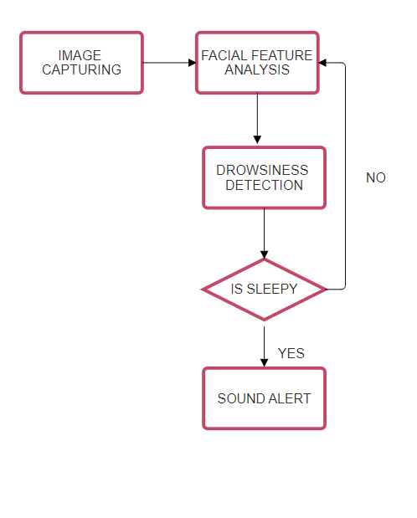
Fig. 2. Data Flow Diagram

Image Capturing
A web camera is the crucial component for any kind of detection systems. The driver drowsiness detection system uses a popular library named as OpenCV (Open Source Computer Vision Library). OpenCV allows users to perform various operations on images, such as resizing, cropping, filtering, and transformations. It provides tools to work with live video data, that includes capturing video from cameras and performing operations like object detection and capture frames in real time. The live data that is captured enables the real time detection. These frames are processed and analysed using computer vision algorithms including Haar cascade and CNN [8].

Haarcascade Integration
The proposed system can perform several complex operations on captured frames and aids in detection of drowsiness in drivers. The accuracy and efficiency of the proposed system also lies in the camera's ability to capture high quality pictures.
There are several algorithms namely "Bayesian classifier”, “Support vector machine" and "haar cascade” [18]. The support Vector machine (SVM) [15] is a machine learning algorithm that is used for face detection and Histogram of oriented gradients (HOG) that uses positive and negative samples for detection. The Bayesian classifier takes fixed size faces and calculates HOG descriptors on them. Whereas, the proposed system takes frames that are captured using the web camera are then processed using the haar cascade classifier. The haarcascade is pre-trained by loading the cascade file namely "haarcascade.xml". This data set is collected from Kaggle and has the folders namely 'yawn’, ‘no-yawn' and 'closed’, ‘open'. The algorithm iterates through labels from the provided path. The proposed system loads images using a haar cascade classifier and detects the faces and draws rectangles which then identifies the region of interest. It resizes the Region of Interest (ROI) to a specified size and appends along with corresponding labels
- 0 for 'yawn'
- 1 for 'no-yawn'
- 2 for 'closed'
- 3 for 'open'
This is then applied to a video that is captured. The trained classifier performs a sliding window approach, which moves over each window and examines each subsection. The classifier calculates haar-like features. The features are simpler rectangular filters that calculate differences between sums of pixels. This classifier uses stages, each containing multiple weak classifiers and it applies a series of these features and decides whether the region being analysed contains the region of interest. Each stage sets the thresholds based on learned patterns from the training data. If the calculated feature values in a window surpass these thresholds, the window moves to the next stage; otherwise, it's rejected early in the process, saving computation time.

Drowsiness Detection
After plotting the rectangles around the region of interest, the code implemented in the proposed model imports all the necessary modules from keras [20]. The facial landmarking is done using the dlib package which considers 68 points as represented in Figure 3. The right eye and left eye are located from 37 to 42 and 43 to 48 respectively and the mouth is located from 49 to 68. The facial features eyes and mouth are taken into consideration as they serve as a indicators. Then CNN is trained with the regions that are extracted. The integrated architecture detects the drowsiness.
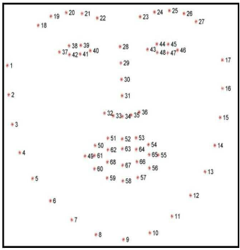
Fig. 3. Facial Landmarks

The EAR ratio is defined as the ratio of distance between horizontal and vertical points of the eye. Figure 4 and Figure 5 represents the horizontal and vertical lines of open eye and closed eye respectively. The proposed model has the pre-set EAR ratio of 0.29[1].
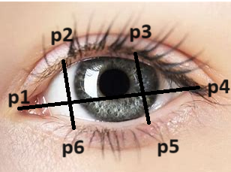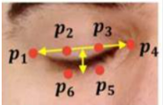
Fig. 4. Open Eye Fig.5. Closed Eye

The Ear Ratio is calculated using the following formula.
EAR = || p2- p6|| + ||p3 - p5||
2||p1-p4|| (1)

The MAR ratio is defined as the ratio of distance between horizontal and vertical points of the mouth. The threshold MAR ratio is 0.45 [1].
Figure 6 represents the vertical [(p1, p5), (p2, p4)] and horizontal lines [p3, p6] of the mouth to calculate the Yawning ratio that is MAR. The MAR ratio is calculated as follows:
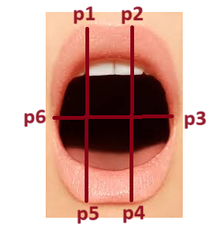
Fig. 6. Yawn

MAR = || p1- p5|| + ||p2 – p4||
2||p6-p3|| (2)
TABLE 1. THRESHOLD VALES
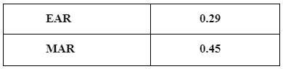
Table 1 represents the threshold values that are set in the proposed system for driver drowsiness detection. An alarm would be triggered if the EAR and MAR values exceed the threshold values.

Alert System
When the calculated values surpass the threshold values, an alert system(buzzer) is triggered according to the frame score. The frame score is calculated in the system in accordance with frequency of drowsiness detection. The frame score is initialized to 0. When the driver exhibits the sign of drowsiness, there would be a drop in the frame score. If the frame score decreases below the pre-set threshold, the alarm starts ringing. The alarm will be continuously triggered till the frame score comes to 0. When the initial frame score is met, the algorithm loops again to detect the facial frames. The camera module in which the image processing and detection is done is connected to arduino. The output pin of arduino is connected to buzzer which activates when the signs of drowsiness are detected. The sound of the buzzer will help in alerting the driver and the passengers as well. Figure 7 depicts the integration of buzzer to the arduino to which the camera is connected. The arduino receives the embedded code from the system and it sends the signals to the buzzer when there is drowsiness detection.
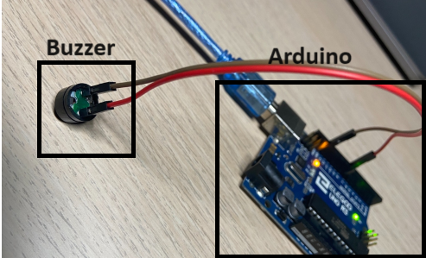

Fig. 7. Implementation of alert system

Figure 8 depicts the detailed architecture of working of the haar cascade in the proposed system
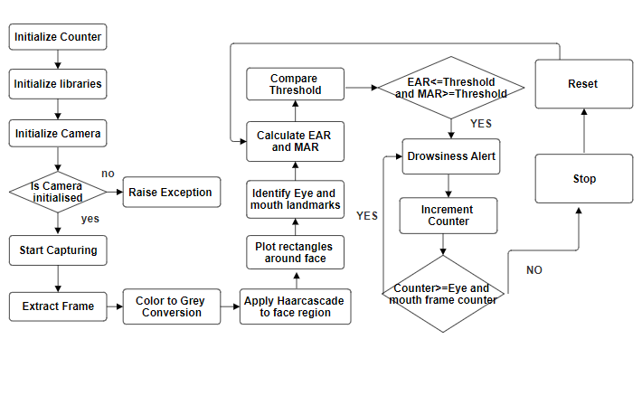
Fig. 8. Detailed Haarcascade architecture

RESULTS AND DISCUSSION
The proposed system uses haar cascade classifier along with CNN to detect signs of drowsiness. When the code is executed, the embedded camera starts capturing the face of the driver. The proposed system detects the drowsiness of the driver as represented in figure 9. This model outputs that the driver is sleeping when the threshold values are exceeded. The alarm is triggered until the frame score goes to 0 again.
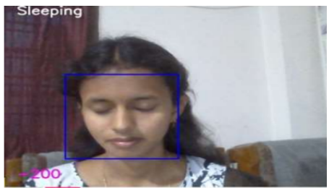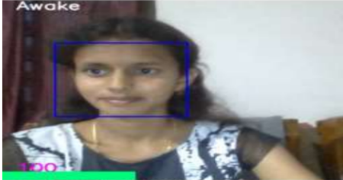
Fig. 9. Drowsiness detection

Table 2 depicts the comparison between Haar cascade and SVM. The metrics used for comparison are precision, recall, F1 score and accuracy of each algorithm.
Table 2. Performance metrics
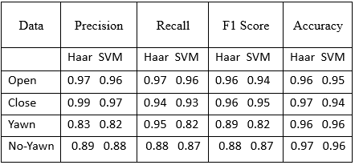

Precision

The haar cascade has exhibited the precision values of 0.97 when the eyes are open, when eyes are closed the precision value is 0.99, driver in yawn state the precision is 0.83, in the case of no yawn precision value is 0.89 and SVM exhibits the precision for open eyes as 0.96, for closed eyes, the precision value is 0.97. The precision values are 0.82 and 0.88 for yawn and no yawn respectively.
The visual representation of comparison of precision between both the algorithms is given in Figure 10.
The precision is calculated as follows:

precision = true positives
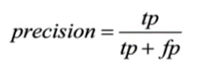
true positives + false positives (3)
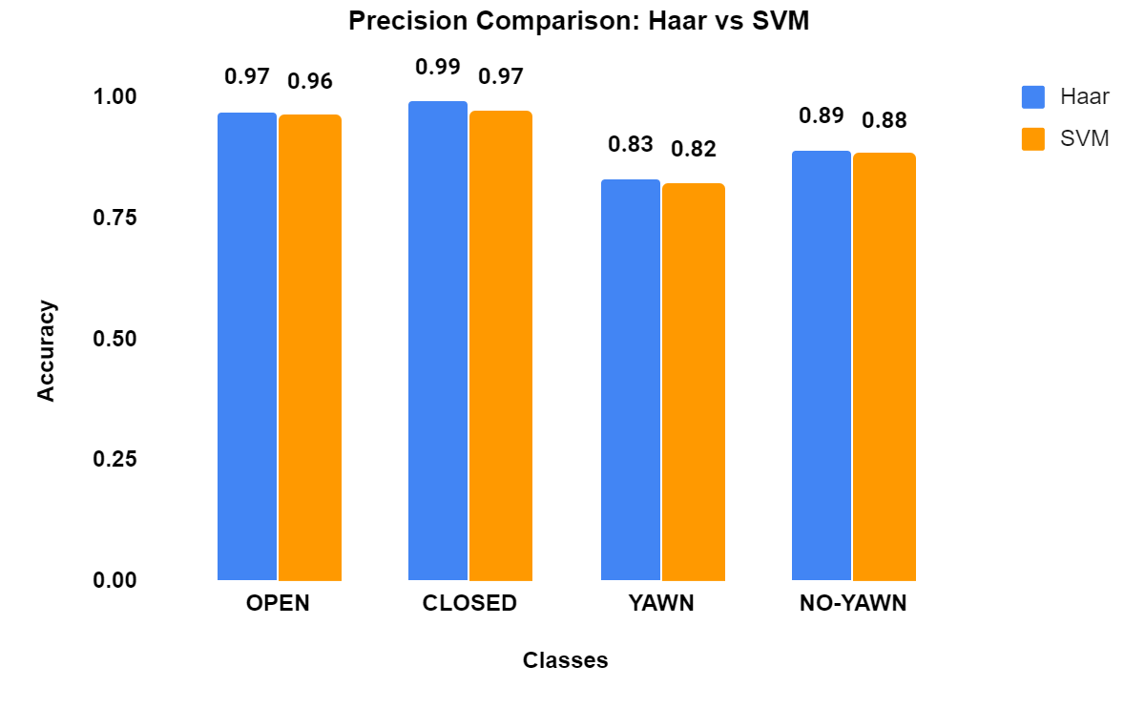
Fig. 10. Precision of Haar cascade vs SVM

Recall
Figure 11 represents the comparison between recall values of SVM and Haar cascade. The Haar cascade has given the highest recall value for open eyes(0.97).
Recall = true positives
true positives + false negatives (4)
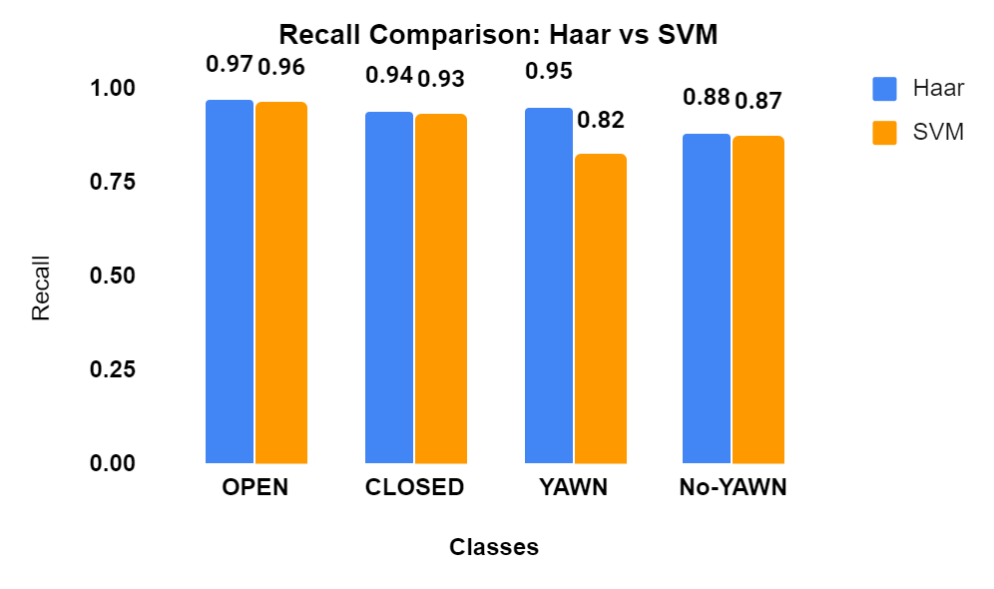
Fig. 11. Recall of Haar cascade vs SVM

F1 Score

Figure 12 represents the comparison between F1 score of SVM and Haar cascade. The Haarcascade has given the similar recall value for open eyes(0.96) and closed eyes(0.96).

F-Measure = (2 * Precision * Recall)
(Precision + Recall) (5)
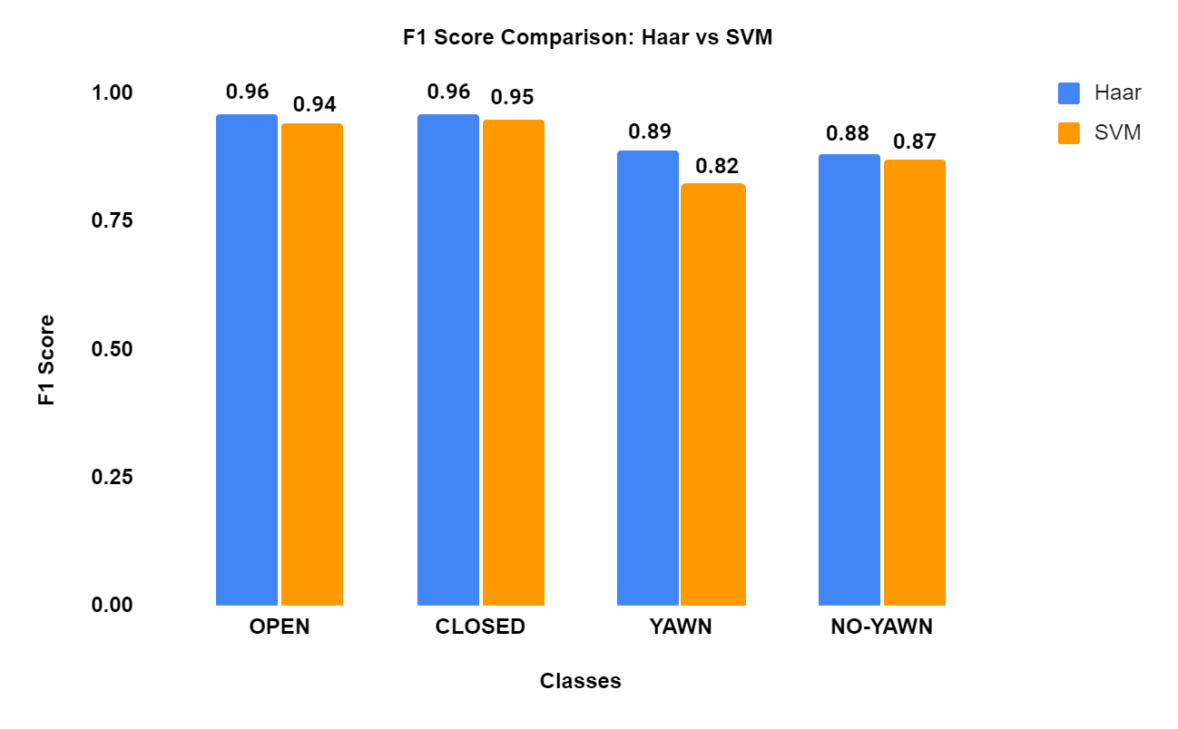
Fig. 12. F1 score of Haar cascade vs SVM

The SVM algorithm has an accuracy of 0.96. The Haar Cascade classifier for object detection has given 0.97 accuracy. Figure 13 represents the accuracy comparison graph between SVM and Haar cascade. This experiment was conducted on 8 different people. It has shown the expected results. Notably, Haar cascade has given more accurate results when compared to support vector machine (SVM). This outcome is due to several factors like simplicity and efficiency of Haar cascade's feature representation, which focuses on capturing basic patterns like edges and textures relevant to drowsiness detection. Haar cascade classifiers typically require less computational resources and training time, making them more practical for real-time applications like driver monitoring systems.
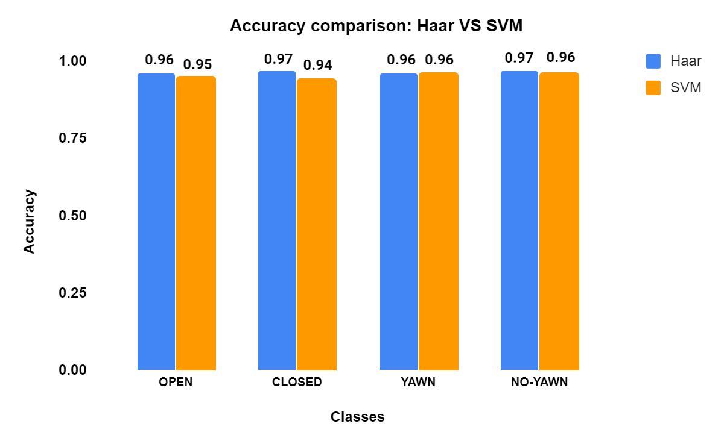
Fig 13. Accuracy of Haar Cascade vs SVM

Conclusion
In conclusion, the utilization of the Haar cascade algorithm in the proposed driver drowsiness detection system has proved to be instrumental in accurately identifying critical facial features, particularly in detecting regions of interest within the extracted frames. The algorithm's efficiency in real-time face detection, along with its ability to detect eye regions, has empowered the system to assess driver alertness levels. The Haar cascade algorithm's adaptive nature has significantly contributed to real-time monitoring, thus enhancing the system's capability to detect signs of drowsiness. Its efficient performance within the system framework has proven pivotal in ensuring reliable and responsive alerts, contributing to safer driving practices and accident prevention. An economical detection system was proposed in this paper which requires some initial investment.

Future scope
The proposed drowsiness detection system can also be integrated with a distraction detection system which alerts the driver to focus on driving. This can be also integrated with the brakes of the vehicle which helps in stopping the vehicles when drowsiness is detected for extended periods.

References

- Rama Devi Burri, K. Swarupa, P. Dileep Sagar, and K. Thanmayee Real-Time Driver Drowsiness Detection Using Visual Behaviour and MTCNN Algorithm (AISC,volume 1415)
- Kumar A, Patra R (2018) Driver drowsiness monitoring system using visual behavior and machine learning. DOI:10.1109/ISCAIE.2018.8405495
- Garg H (2020) Drowsiness detection of a driver using conventional computer vision application. In: International conference on power electronics & IoT applications in renewable energy and its control (PARC)
- Dua HK, Goel S, Sharma V (2018) Drowsiness detection and alert system. In: International conference on advances in computing, communication control and networking (ICACCCN) .
- Praveen Kumar V, Aravind P, Nachammai Devi Pooja S, Prathyush S, Angel Deborah S, Sarath Chandran KR (2021) Driver assistance system using raspberry pi and haar cascade classifiers. In: 5th international conference on intelligent computing and control systems (ICICCS)
- Dasgupta A, Rahman D, Routray A (2019) A smartphone-based drowsiness detection and warning system for automotive drivers. IEEE Trans Intell Transp Syst
- Ou WL, Shih MH, Chang CW, Yu XH, Fan CP (2015) Intelligent video-based drowsy driver detection system under various illuminations and embedded software implementation. In: 2015 international conference on consumer electronics, Taiwan
- Burri RD, Madhuri A, Raghavendra Sai N (2020) A multi resolution convolution neural network based face recognition analysis. J Crit Rev 7(18). ISSN: 2394-5125
- Fouzia, Roopalakshmi R, Rathod JA, Shetty AS, Supriya K (2018) Driver drowsiness detection system based on visual features. In: Proceedings of the 2nd international conference on inventive communication and computational technologies (ICICCT)
- Rateb Jabbar, Khalifa Al-Khalifa, Mohamed Kharbeche, Wael Alhajyaseen, Mohsen Jafari, Shan Jiang, Real-time Driver Drowsiness Detection for Android Application Using Deep Neural Networks Techniques, Procedia Computer Science, Volume 130, 2018
- Dua, M., Shakshi, Singla, R., Raj, S., & Jangra, A. (2020). Deep CNN models-based ensemble approach to driver drowsiness detection. Neural Computing and Applications. doi:10.1007/s00521-020-052097
- Danisman T, Bilasco IM, Djeraba C, Ihaddadene N. Drowsy driver detection system using eye blink patterns. Machine and Web Intelligence (ICMWI) IEEE 2010;230-233.
- 9. Viola, P., Jones, M. Rapid object detection using a boosted cascade of simple features. Computer Vision and Pattern Recognition, IEEE Computer Society Conference.2001;I:I
- Hariri B, Abtahi S, Shirmohammadi S, Martel L. A yawning measurement method to detect driver drowsiness.
- DRIVER FATIGUE MONITORING SYSTEM USING SUPPORT VECTOR MACHINES ,Matthew Sacco, Reuben A. Farrugia Department of Communications and Computer Engineering University of Malta.
- Harshith Verma et al, Driver drowsiness detection. https://sjcjycl.cn/ DOI: 10.5281/zenodo.776772
- S. D. S. G. A. J. B. Sukrit Mehta, "Real-Time Driver Drowsiness Detection System Using Eye Aspect Ratio and Eye Closure Ratio," in Proceedings of International Conference on Sustainable Computing in Science, Technology and Management (SUSCOM), Amity University Rajasthan, Jaipur - India, 2019.
- W. K. H. K. C. B. T. J. Kyong Hee Lee, "A Study on Feature Extraction Methods Used to Estimate a Driver’s Level of Drowsiness", International Conference on Advanced Communications Technology (ICACT), 2019.
- R. P. Ashish Kumar, "Driver Drowsiness Monitoring System using Visual Behaviour and Machine Learning," IEEE Conference, 2018.
- Vedant Kaushish, Nitesh Singh, Kunal Maggo, Preeti Nagrath, Rachna Jain, "Driver Drowsiness Detection System with OpenCV and Keras," in Proceedings of the International Conference on Innovative Computing & Communication (ICICC), 2021.
- M. D. Y. L. W. Chen, "Real-time driver drowsiness detection using convolutional neural networks.," IEEE Transactions on Intelligent Transportation Systems, vol. 18, no. 8, pp. 2189-2198, 2017.
- G. Bradski, "The OpenCV Library. Dr. Dobb's Journal of SoftwareTools,"2000.[Online]https://www.drdobbs.com/embedded-systems/the-opencv-library/184404319.
- D. R. A. &. R. R. De Silva, " Drowsiness Detection for Driver Safety: A Review," IEEE International Conference on Artificial Intelligence and Virtual Reality (AIVR), pp. 258-263, 2020.
- Krajewski J, Sommer D, Trutschel U, Edwards D, Golz M. Steering wheel behavior based estimation of fatigue. The fifth international driving symposium on human factors in driver assessment, training and vehicle design 2009;118-124.
- Parkhi OM, Vedaldi A, Zisserman A. Deep Face Recognition. British Machine Vision Conference (BMVC) 2015;1:6.
- https://www.nhtsa.gov/risky-driving/drowsy-driving

